#Import the dataset and do usual exploratory analysis steps like checking the structure & characteristics of the dataset:

A)Data type of all columns in the "customers" table.

select
column_name,
data_type
from dsmljunior.Target_SQL.INFORMATION_SCHEMA.COLUMNS
limit 5

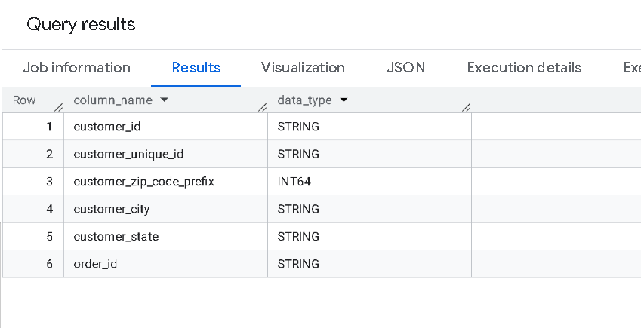
Insights : Most of the data-type in Customers table is of String Type

B) Get the time range between which the orders were placed.
select
CONCAT (min(order_purchase_timestamp), " TO " ,
max(order_purchase_timestamp))
from `Target_SQL.orders`

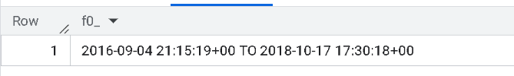
Insights :
Time range is between
4th Sept 2016 9: 15 pm to 17th Oct 2018 5.30 pm

C) Count the Cities & States of customers who ordered during the given period.

SELECT
count(DISTINCT c.customer_city) as Count_cities,
count(DISTINCT c.customer_state) as count_state
FROM `Target_SQL.customers ` as c JOIN `Target_SQL.orders` AS o
on c.customer_id = o.customer_id

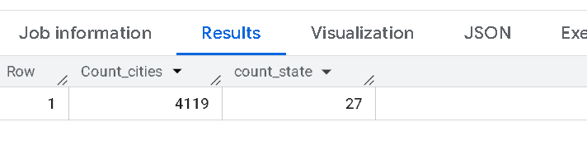
Insights :
No of distinct cities of customers where order has been placed are 4119
No of States of customers where order has been placed are 27

It shows the customers are from 27 states and 4119 cities within those states

Actions: City wise insights would be usable for segmenting customers based on precious orders

2. In-depth Exploration:
A) Is there a growing trend in the no. of orders placed over the past years?
SELECT
Extract (Year from order_purchase_timestamp)
AS PERIOD,
COUNT(ORDER_ID) AS NO_OF_ORDERS FROM `Target_SQL.orders`
group by PERIOD
order by period asc

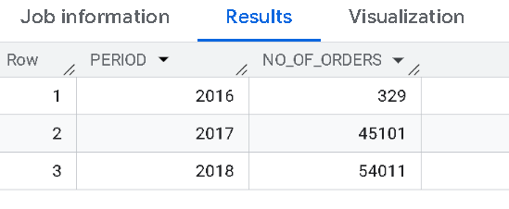
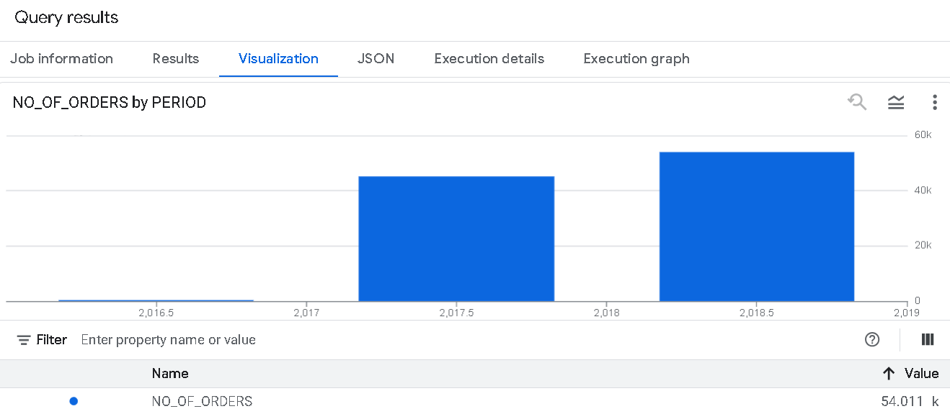

Insights : There is growing trend as per graph and data but good grown from 2016 to 2017 , very less growth from 2017 to 2018.
Action : Company should brainstorm why there is less growth in 2017 to 2018 yoy as comparison to 2016 to 2017

B) Can we see some kind of monthly seasonality in terms of the no. of orders being placed?

SELECT
EXTRACT(YEAR FROM order_purchase_timestamp) as order_year,
EXTRACT(MONTH FROM order_purchase_timestamp) as order_month,
COUNT(order_id) AS total_orders
FROM
`Target_SQL.orders`
GROUP BY order_year, order_month
ORDER BY order_year, order_month

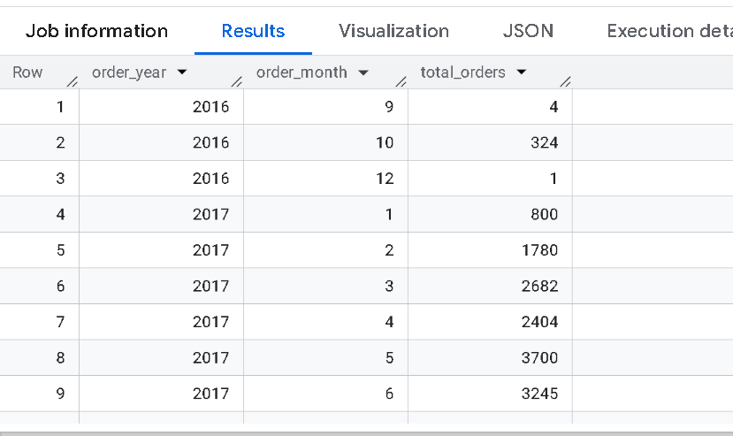

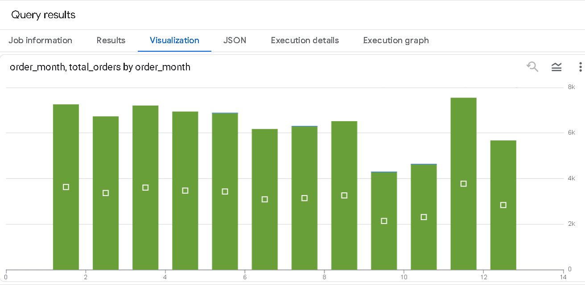

Insights : There is drop in the month 8th to 11th in the number of orders in 2017

C) During what time of the day, do the Brazilian customers mostly place their orders? (Dawn, Morning, Afternoon or Night)
#0-6 hrs : Dawn
#7-12 hrs : Mornings
#13-18 hrs : Afternoon
#19-23 hrs : Night

SELECT
CASE
WHEN EXTRACT(HOUR FROM order_purchase_timestamp) BETWEEN 0 AND 6 THEN 'Dawn'
WHEN EXTRACT(HOUR FROM order_purchase_timestamp) BETWEEN 7 AND 12 THEN 'Mornings'
WHEN EXTRACT(HOUR FROM order_purchase_timestamp) BETWEEN 13 AND 18 THEN 'Afternoon'
ELSE 'Night'
END AS Time_of_Day,
COUNT(order_id) AS Orders_Placed
FROM
`Target_SQL.orders`
GROUP BY
Time_of_Day
ORDER BY
Orders_Placed DESC;

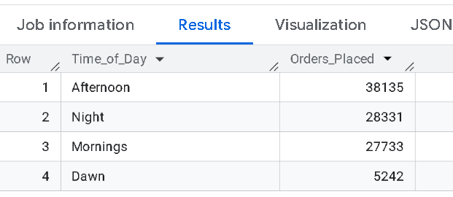

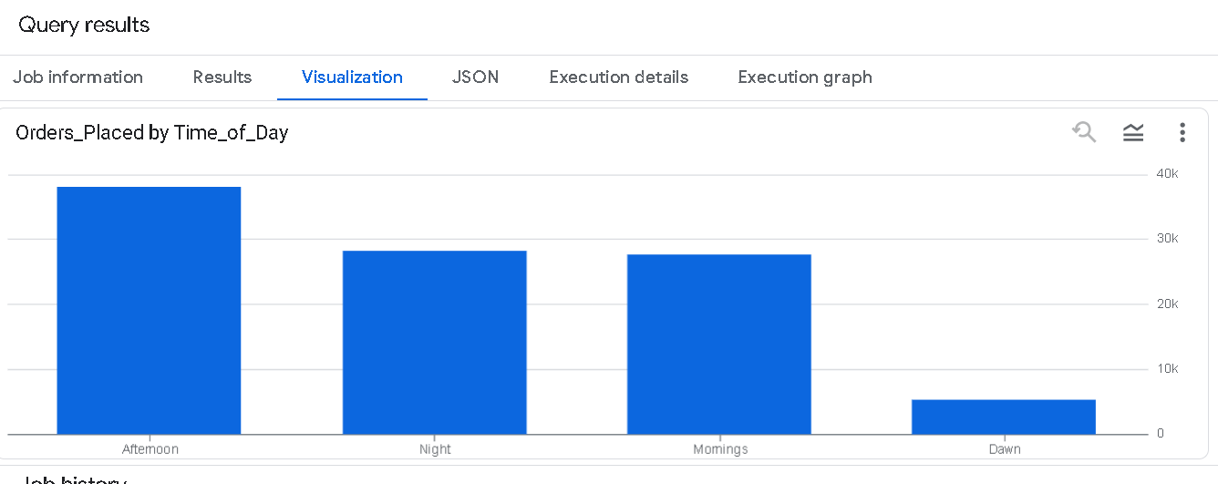
Insights: the Brazilian customers mostly place their orders in the afternoon then in nights and then in the morning but very less at the dawn

3. Evolution of E-commerce orders in the Brazil region:
A) Get the month on month no. of orders placed in each state.

with cte1 as
(
Select
c.customer_state,
format_timestamp("%Y-%m",o.order_purchase_timestamp) as yr_month,
count(*) as number_of_orders
from `Target_SQL.customers ` c
join `Target_SQL.orders` o
using (customer_id)
where o.order_status not in ("Completed","Cancelled")
group by c.customer_state,yr_month
order by c.customer_state,yr_month
) select * from cte1
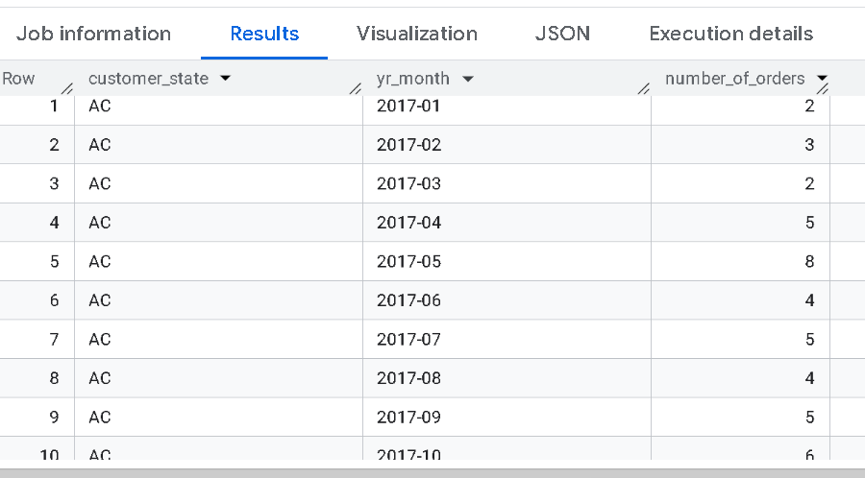
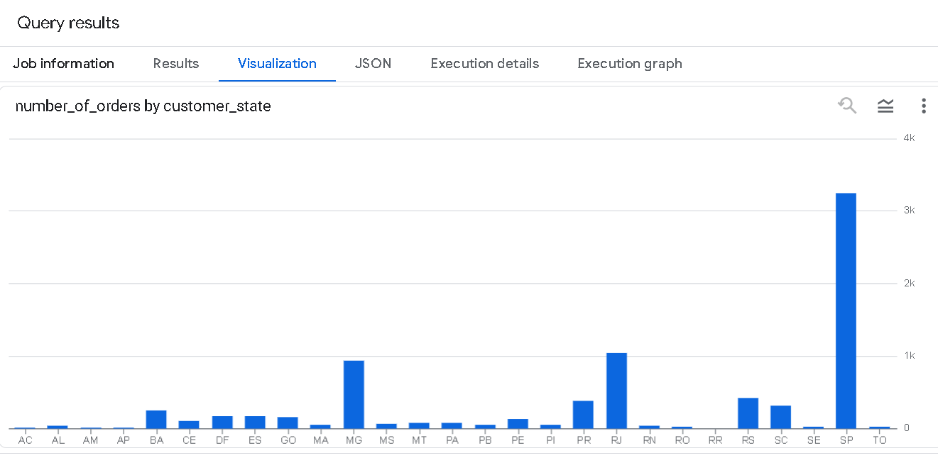
Insights : State name SP has highest number of orders placed
B) How are the customers distributed across all the states?

Select
customer_state as state,
count(customer_unique_id) as number_of_customers
from `Target_SQL.customers `
group by customer_state
order by number_of_customers desc

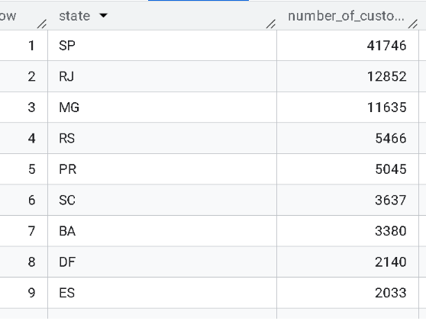

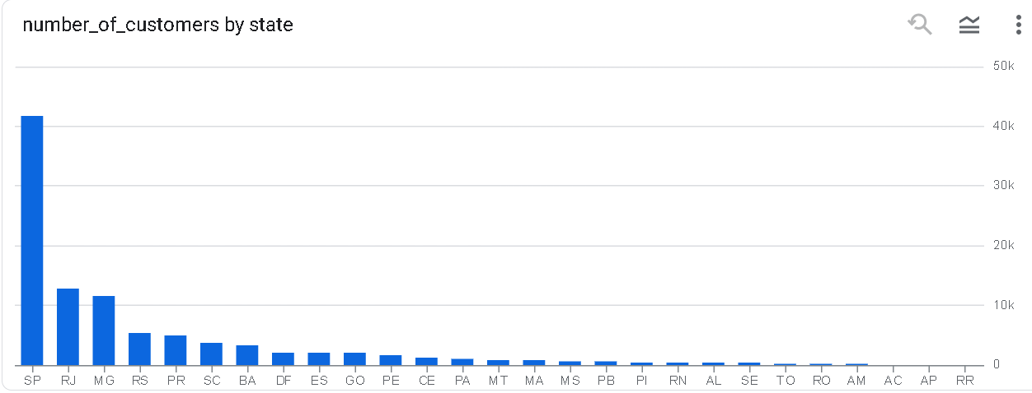

Insights : State SP has high number of customers

4. Impact on Economy: Analyze the money movement by e-commerce by looking at order prices, freight and others.

- Get the % increase in the cost of orders from year 2017 to 2018 (include months between Jan to Aug only).

#You can use the “payment_value” column in the payments table to get the cost of orders.

with cte1 as
( Select
extract (year from o.order_purchase_timestamp) as year,
extract (month from o.order_purchase_timestamp) as month,
Sum(payment_value) as amount
from `Target_SQL.payments` as p join `Target_SQL.orders`
as o using (order_id)
group by o.order_purchase_timestamp
order by year
), cte2 as
(
select
round(sum(case when year = 2017 then amount else 0 end),2) as cost_2017,
round(sum(case when year = 2018 then amount else 0 end),2) as cost_2018
from cte1
where month < 9 and year > 2016
)
select
*,round((cost_2018-cost_2017)/cost_2017*100,2) as percentage_increase_yoy
from cte2

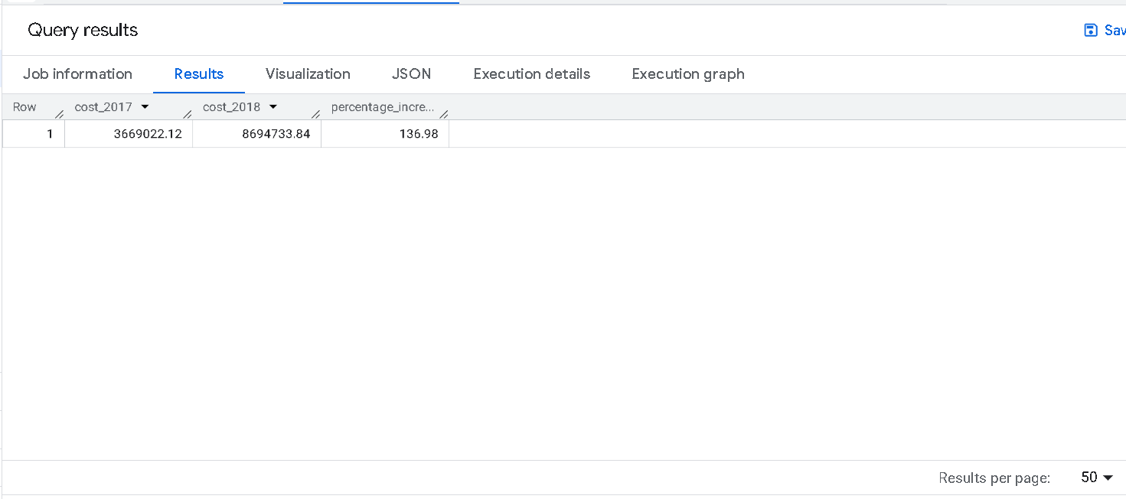

Insights : The percentage increase from 2017 to 2018 for cost of order is 136%

- Calculate the Total & Average value of order price for each state.
Select
c.customer_state as state,
round(sum(oi.price),2) as total_order_price,
round(sum(oi.price)/count(distinct order_id),2) as avg_order_price
from `Target_SQL.customers ` c join `Target_SQL.orders` o using (customer_id)
join `Target_SQL.order_items` oi using(order_id)
group by state

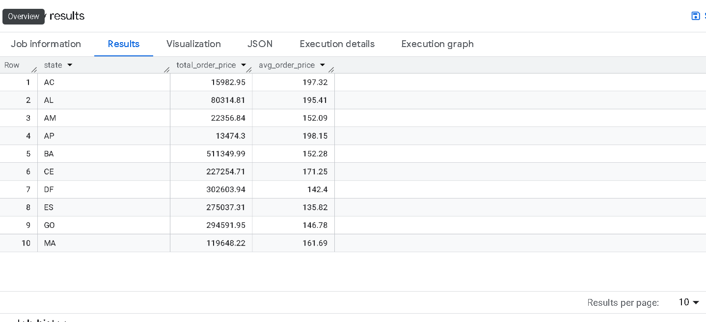
Insights : Max Total Order_Price is from BA state and the biggest avg_order is from AP state
- Calculate the Total & Average value of order freight for each state.

Select
c.customer_state as state,
round(sum(oi.freight_value),2) as total_order_freight,
round(sum(oi.freight_value)/count(distinct order_id),2) as avg_order_freight
from `Target_SQL.customers ` c join `Target_SQL.orders` o using (customer_id)
join `Target_SQL.order_items` oi using(order_id)
group by state
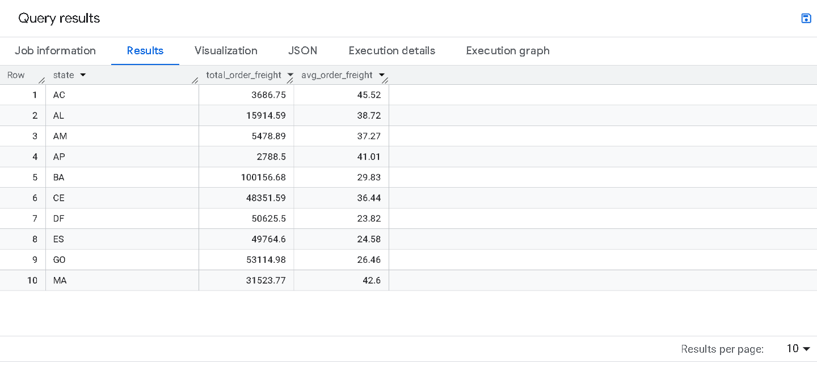Insights : Avg Order_ Freight is max in State BA, Total_Order_Freight is max in State AC

5. Analysis Based on sales, freight and delivery time

- Find the no. of days taken to deliver each order from the order’s purchase date as delivery time.
Also, calculate the difference (in days) between the estimated & actual delivery date of an order.
Do this in a single query.

You can calculate the delivery time and the difference between the estimated & actual delivery date using the given formula:
time_to_deliver = order_delivered_customer_date - order_purchase_timestamp
diff_estimated_delivery = order_estimated_delivery_date - order_delivered_customer_date
*/

Select
order_id,
date_diff(order_delivered_customer_date,order_purchase_timestamp,day) as time_to_deliver,
date_diff(order_estimated_delivery_date,order_delivered_customer_date,day)diff_estimated_delivery
from
`Target_SQL.orders`

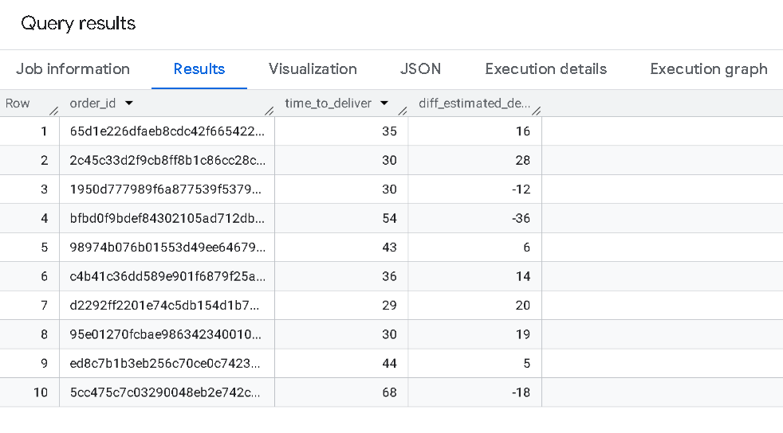

Insights :

Average delivery time is range from 29 to 69 days, whereas on time or early delivery are approx. 30% and rest 70 % order deliveries are delayed
Action Required : To improve the timely delivery of orders and and increase the ‘on time’ delivery metric.

- Find out the top 5 states with the highest & lowest average freight value.*/
(
Select
c.customer_state as state,
'Highest' as val,
round(avg(oi.freight_value),2) as avg_order_freight
from `Target_SQL.customers ` c join `Target_SQL.orders` o using (customer_id)
join `Target_SQL.order_items` oi using(order_id)
group by state
order by avg_order_freight desc
limit 5
)
UNION ALL
(
Select
c.customer_state as state,
'Lowest' as value,
round(avg(oi.freight_value),2) as avg_order_freight
from `Target_SQL.customers ` c join `Target_SQL.orders` o using (customer_id)
join `Target_SQL.order_items` oi using(order_id)
group by state
order by avg_order_freight asc
limit 5
)

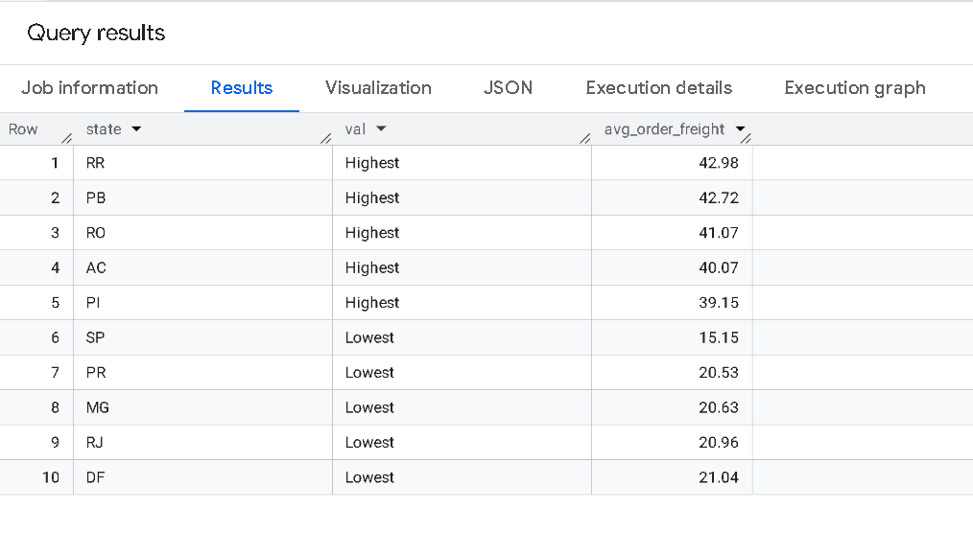
Insights : Top 5 Highest avg_Order_Freight_Value States and Top 5 Lowest avg_order_freight_value has been shown

- *Find out the top 5 states with the highest & lowest average delivery time.

(
Select
c.customer_state as state,
'Highest' as val,
round(avg(date_diff(order_estimated_delivery_date,order_delivered_customer_date,day)),0) as avg_delivery,
from `Target_SQL.customers ` c join `Target_SQL.orders` o using (customer_id)
join `Target_SQL.order_items` oi using(order_id)
group by state
order by avg_delivery desc
limit 5
)
UNION ALL
(
Select
c.customer_state as state,
'Lowest' as value,
round(avg(date_diff(order_estimated_delivery_date,order_delivered_customer_date,day)),0) as avg_delivery,
from `Target_SQL.customers ` c join `Target_SQL.orders` o using (customer_id)
join `Target_SQL.order_items` oi using(order_id)
group by state
order by avg_delivery asc
limit 5
)

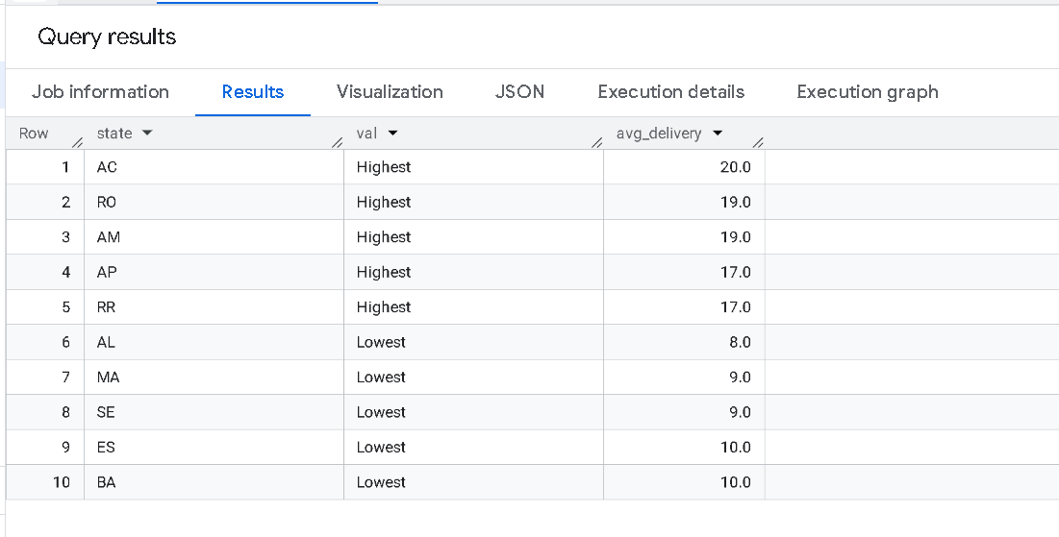

Insights : Average Delivery Date : Slowest is 17-20 days and Fastest is 8-10 days

- *Find out the top 5 states where the order delivery is really fast as compared to the estimated date of delivery.
You can use the difference between the averages of actual & estimated delivery date to figure out how fast the delivery was for each state.
*/
with cte as
(
Select
c.customer_state,
round(avg(date_diff(o.order_estimated_delivery_date,o.order_delivered_customer_date,day)),0) as fast_metric
from `Target_SQL.customers ` c join `Target_SQL.orders` o using(customer_id)
join `Target_SQL.order_items` oi using (order_id)
group by customer_state
)
select cte.customer_state,
cte.fast_metric as avg_delivery_time
from
cte
order by cte.fast_metric asc
limit 5

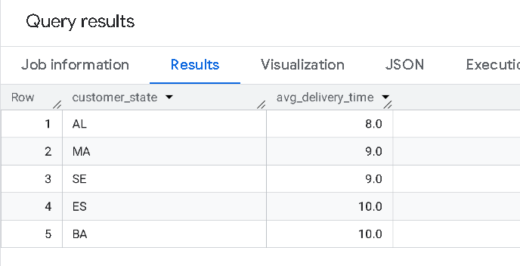
Insights:
Top 5 states with fastest avg_delivery_time

6. Analysis based on payments
A) Find the month on month no. of orders placed using different payment type

select
format_timestamp('%Y-%m', o.order_purchase_timestamp)as month,
p.payment_type,
count(o.order_id) as number_of_orders
from `Target_SQL.payments` as p join `Target_SQL.orders` as o using (order_id)
where payment_type is not null and order_status not in ('canceled','unavailable')
group by month,payment_type
order by month,payment_type

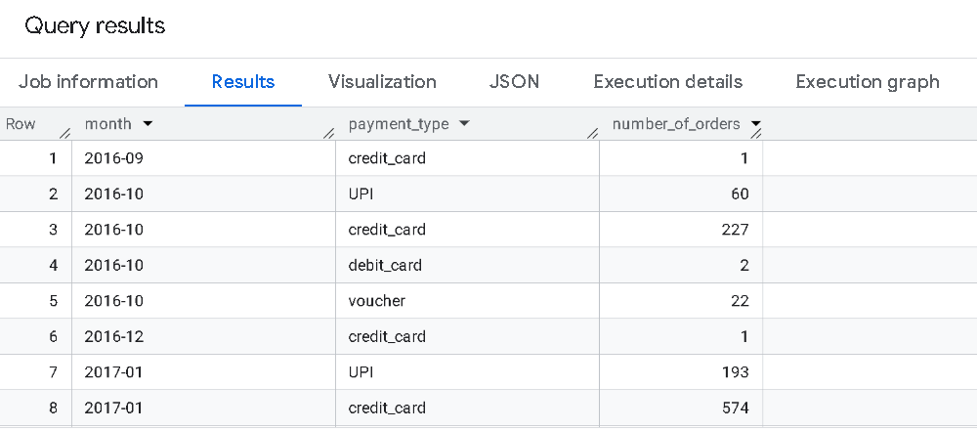

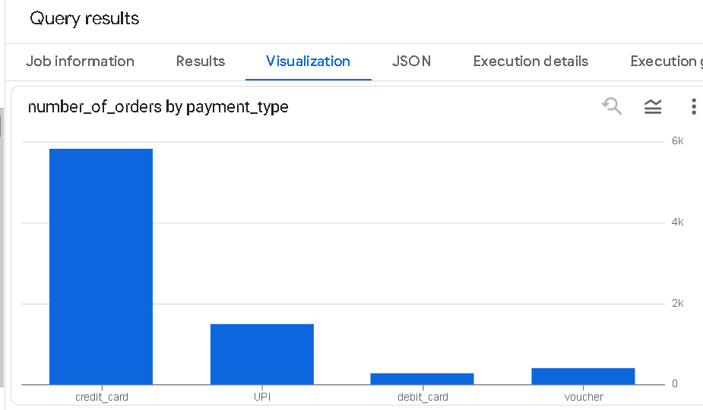

Insights : Majority Ordering has been done through credit card since 2017
B) Find the no. of orders placed on the basis of the payment installments that have been paid.

Select
payment_installments,
Count(order_id) as no_of_orders
from `Target_SQL.payments`
where payment_installments >=1
group by payment_installments
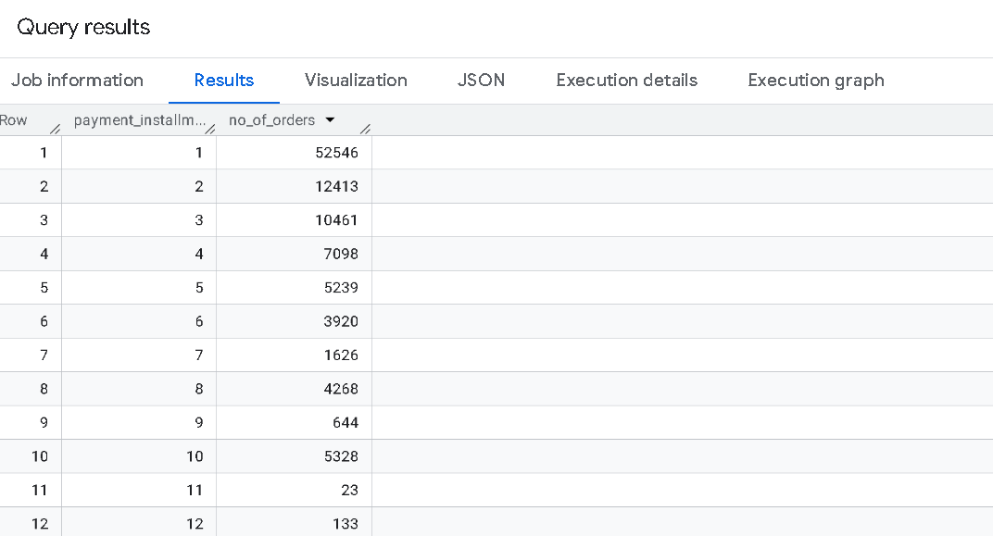

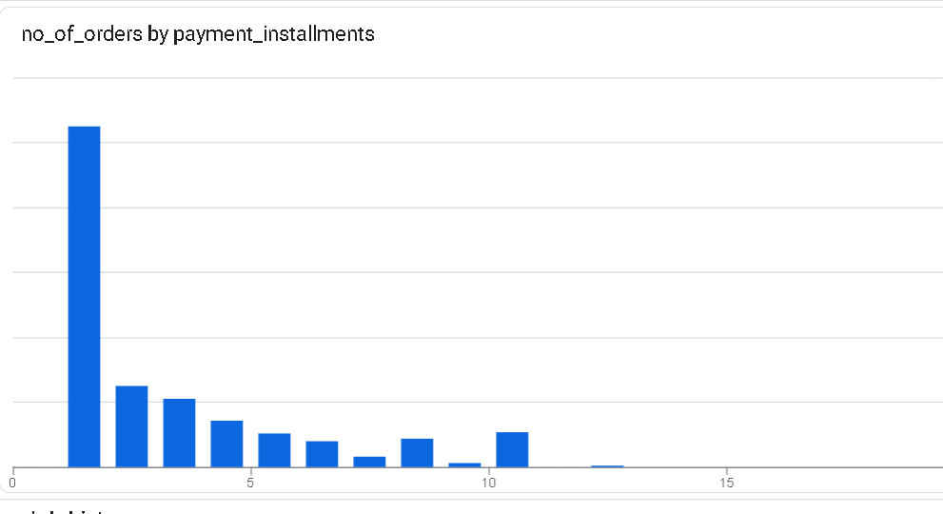
Insights : Majority Orders are placed with one instalment has been paid.

